SHORT TERM GOAL- TEST 4

Probability expressions
    - interpret commonly used probability statements, including ‘possible’, ‘probable’, ‘likely’, ‘certain’
    - describe ways of expressing probabilities formally using fractions, decimals, ratios and percentages

Simple probabilities in practical situations
    - construct a sample space for an experiment which represents a practical situation
    - use a sample space to determine the probability of outcomes for an experiment
    - use arrays or tree diagrams to determine the outcomes and the probabilities for experiments

Location
    - locate positions on the earth’s surface given latitude and longitude using a range of methods; for example, a global positioning system (GPS), a globe, an atlas and digital technologies
    - use the arc length formula to calculate distances between two places on Earth on the same longitude
    - determine distances between two places on Earth using appropriate technology

Time
    - understand the link between longitude and time
    - solve problems involving time zones in Australia and neighbouring nations making any necessary allowances for daylight saving
    - solve problems involving Greenwich Mean Time and the International Date Line
    - determine time differences between two places on Earth
    - solve problems associated with time zones; for example, internet and phone usage
    - solve problems relating to travelling east and west, incorporating time zone chan

Term 3 Week 4 Check point- World Locations and Probability- You will need to write your answers in your Interactive notebook

1. | 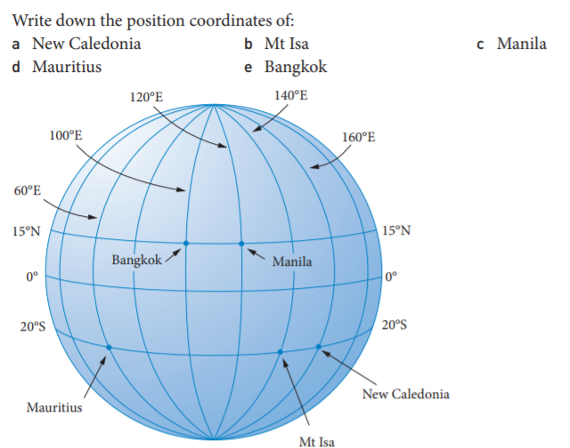
2.
3. | Calculate the difference in latitude between these cities, and state whether the second city listed is north or south of the first.  - Shanghai, China (31°N, 121°E) and New York, USA (40°N, 64°W)  - Nairobi, Kenya (1°S, 37°E) and Bangkok, Thailand (13°N, 100°E)  - Moscow, Russia (55°N, 37°E) and London, UK (51°N, 0°)  - Auckland, NZ (37°S, 174°E) and Canberra (35°S, 149°E)  - Melbourne (37°S, 145°E) and Cairo, Egypt (30°N, 31°E)  (f) Newcastle (33°S, 151°E) and West Wyalong (34°S, 147°E)
4. | Beijing, China and Perth have coordinates (40°N, 116°E) and (32°S, 116°E) respectively. Calculate the shortest distance between Beijing and Perth, to the nearest kilometre, given that the Earth’s radius is 6400 km
5. | For a survey, a student counted the vehicles driving out of a sports complex at the end of day 1 of a sports carnival. She recorded the results in a table as shown below.  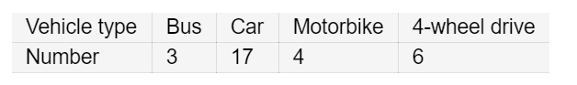  Assuming that on day 2 there is a similar traffic movement, what is the probability that a randomly selected vehicle will be:  - a car  - a bus  - not a 4-wheel drive?
6. | - Draw a tree diagram to show the combined experiment, tossing a coin and spinning a circular spinner with four equal sectors labelled 1, 2, 3, 4.  - Determine the probability of each possible result.  - What do you notice about the sum of the probabilities?  - Calculate the probability of obtaining:  - Heads and an even number  - a prime number  - Tails.

ANSWERS:
1.
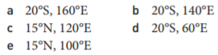
2. Mauritus
3. a) 9
b) 14

4.

5.
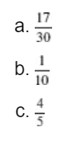
6.

